**Question # 1.**

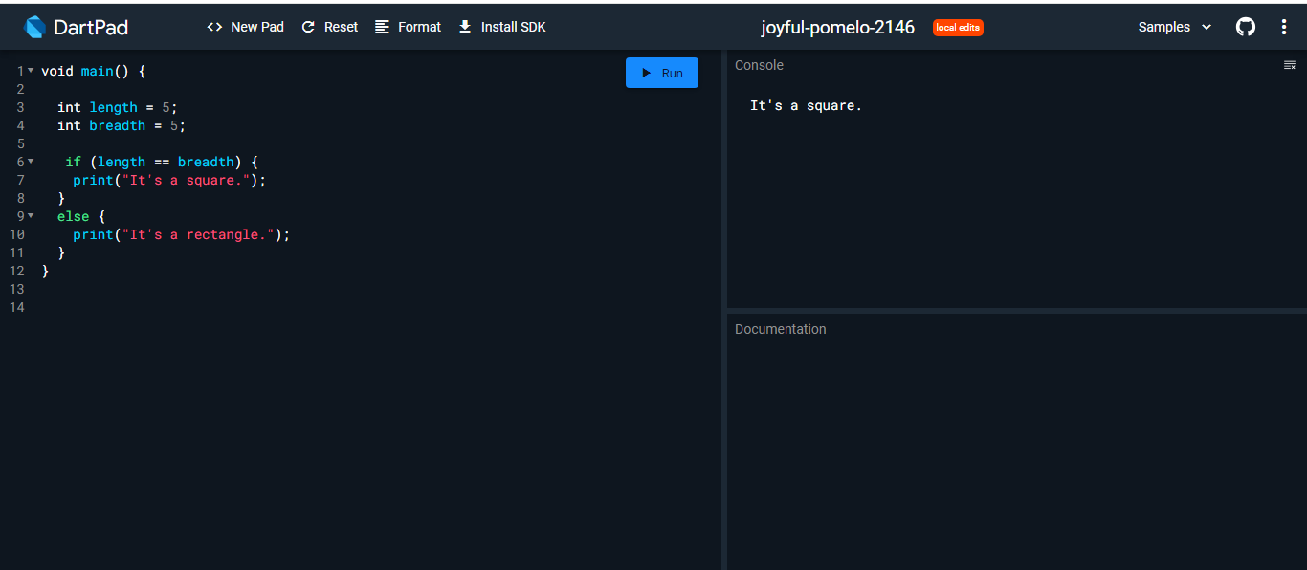

**Question # 2.**

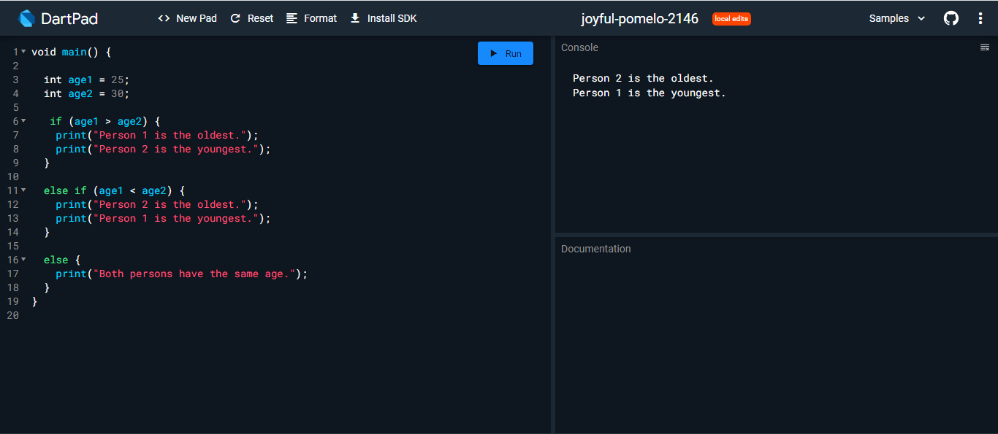

**Question # 3.**

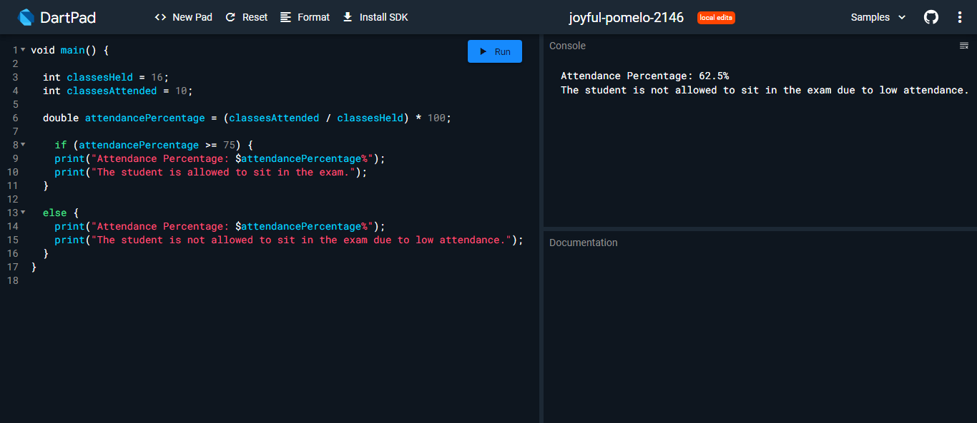

**Question # 4.**

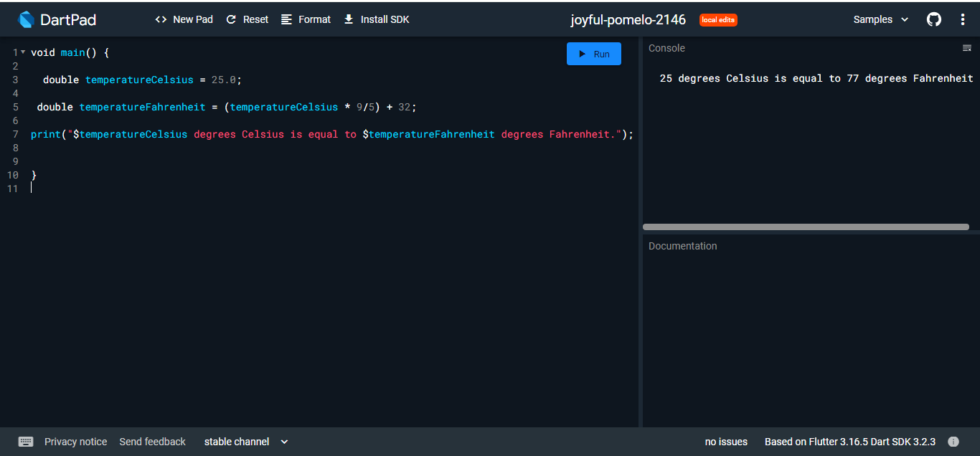

**Question # 5.**

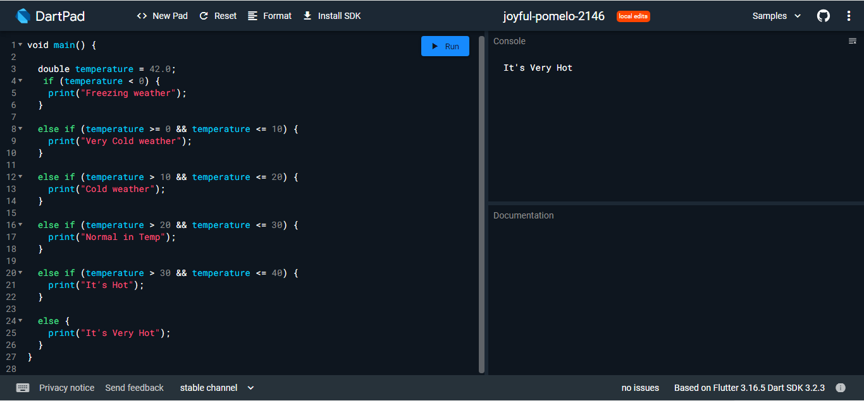

**Question # 6.**

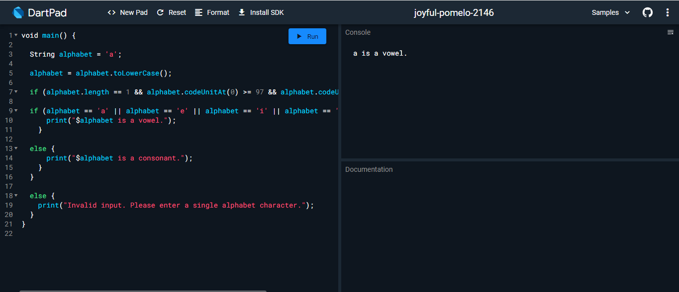

**Question # 7.**

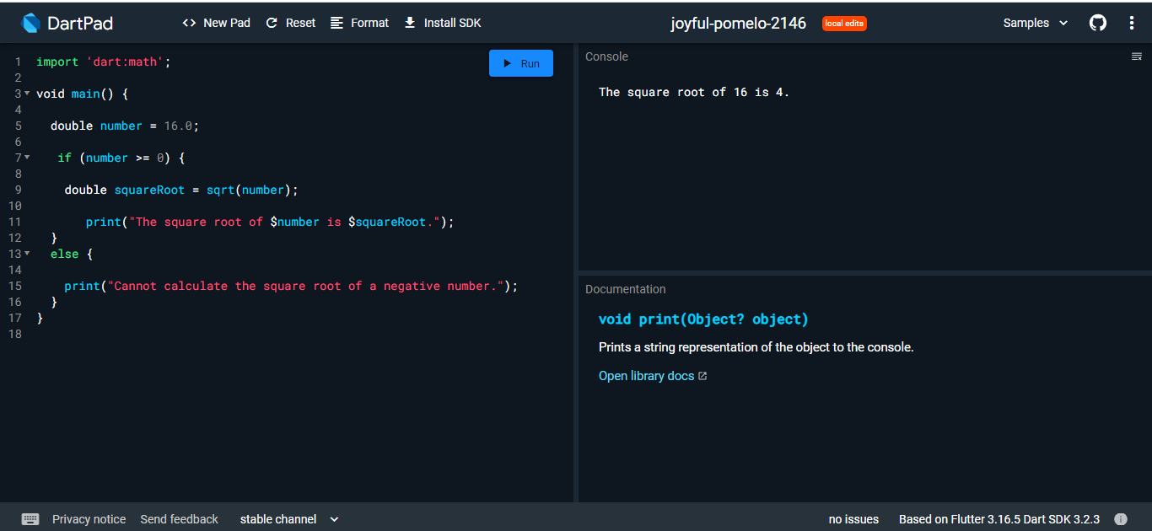

**Question # 8.**

**void main() {**

**String studentName = "Hareb Khan";**

**int rollNumber = 12345;**

**String studentClass = "10th Grade";**

**int subject1 = 80;**

**int subject2 = 90;**

**int subject3 = 75;**

**int subject4 = 85;**

**int subject5 = 95;**

**int totalMarks = subject1 + subject2 + subject3 + subject4 + subject5;**

**double percentage = (totalMarks / 500) * 100;**

**String grade;**

**if (percentage >= 90) {**

**grade = "A+";**

**} else if (percentage >= 80) {**

**grade = "A";**

**} else if (percentage >= 70) {**

**grade = "B";**

**} else if (percentage >= 60) {**

**grade = "C";**

**} else {**

**grade = "D";**

**}**

**print("Student Name: $studentName");**

**print("Roll Number: $rollNumber");**

**print("Class: $studentClass");**

**print("Total Marks: $totalMarks");**

**print("Percentage: ${percentage.toStringAsFixed(2)}%");**

**print("Grade Obtained: $grade");**

**}**

**Console**

**Student Name: Hareb Khan**

**Roll Number: 12345**

**Class: 10th Grade**

**Total Marks: 425**

**Percentage: 85.00%**

**Grade Obtained: A**

**Question # 9.**

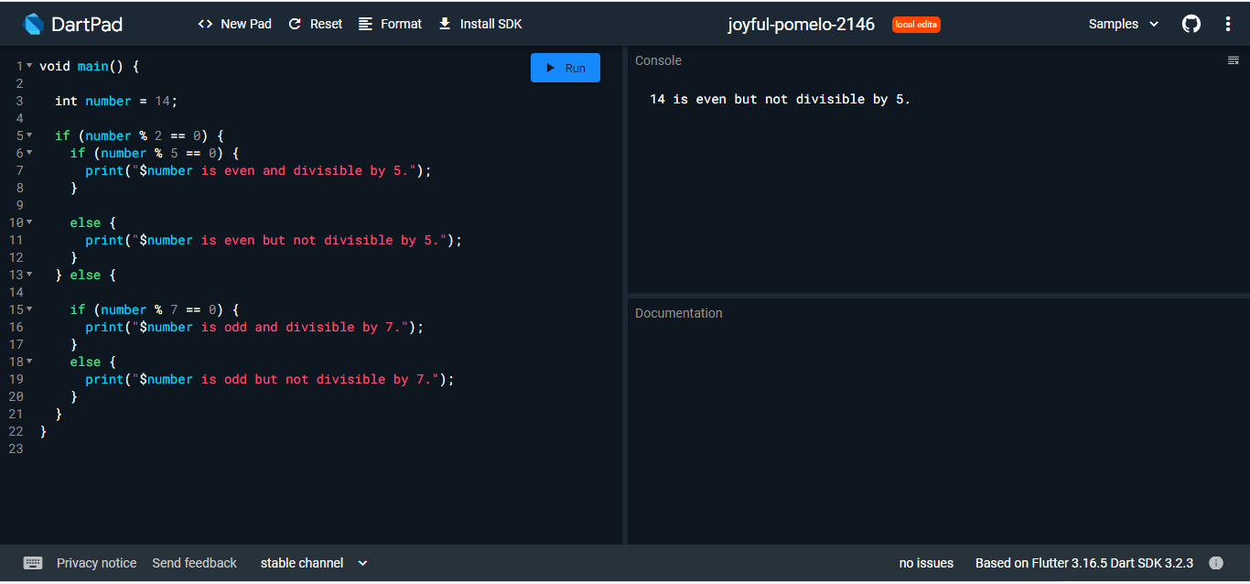

**Question # 10.**